1. Read the question and the student’s answer carefully.
2. Use the mark scheme to award the student a number of marks and annotate their answer with suggestions to improve.
Stretch: Rewrite the answer to show how it should be done!

Question:
Aluminium can be separated from its ore by electrolysis. The equation for the reaction is:
2 Al₂O₃ (l) 4 Al (s) + 3 O₂ (g)

Calculate the mass of aluminium that could be obtained from 2 kg of aluminium oxide. (6)
Student answer:
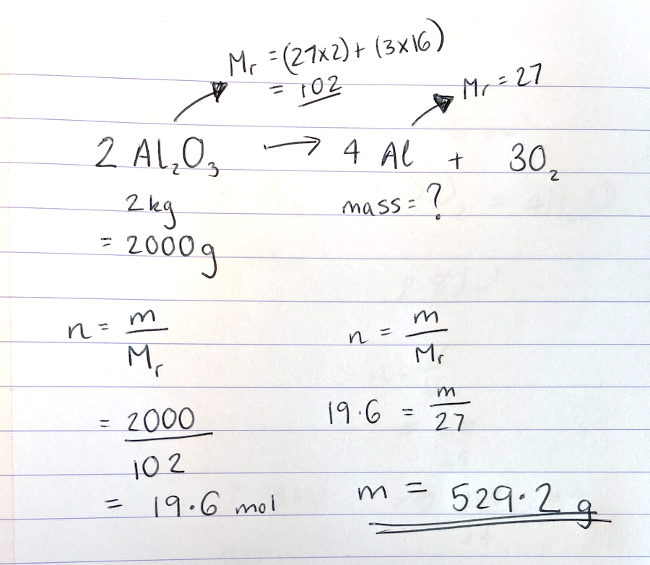

Marks awarded= _______
Mark scheme:

Point | Mark
Mr Al₂O₃ = 102 | 1 (answer, can also be shown in working of next point)
Number of moles Al₂O₃ = m/Mr  2000/102 | 1 (substitution)
Number of moles Al₂O₃ = 19.6.078…mol | 1 (answer)
Mole ratio= 2:4  Number of moles Al = 39.2156… | 1 (number of moles Al)
Mass Al = n x Mr  = 39.2156 x 27 | 1 (substitution)
1 058.82 g | 1 (answer)

